RIVERA, JIAN CARLO D. BSIT301

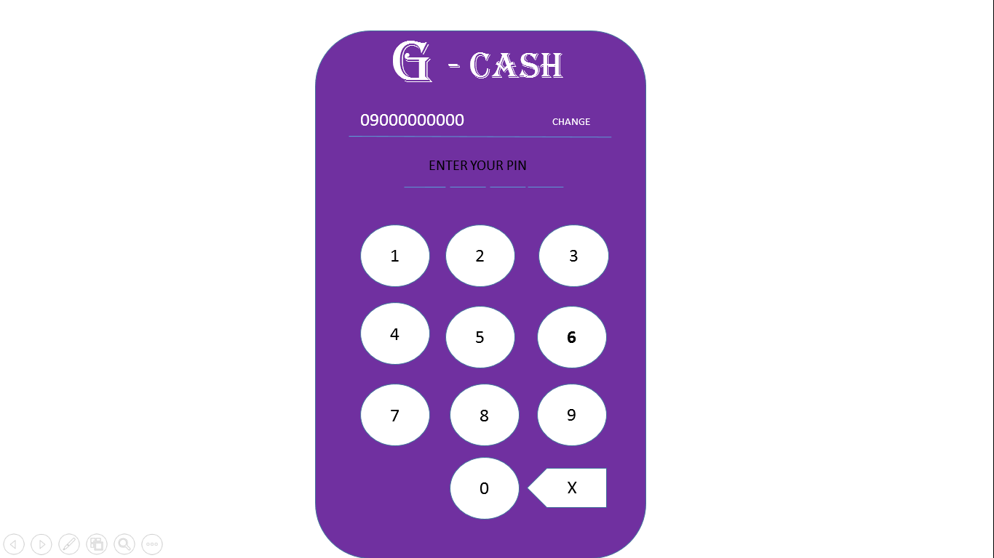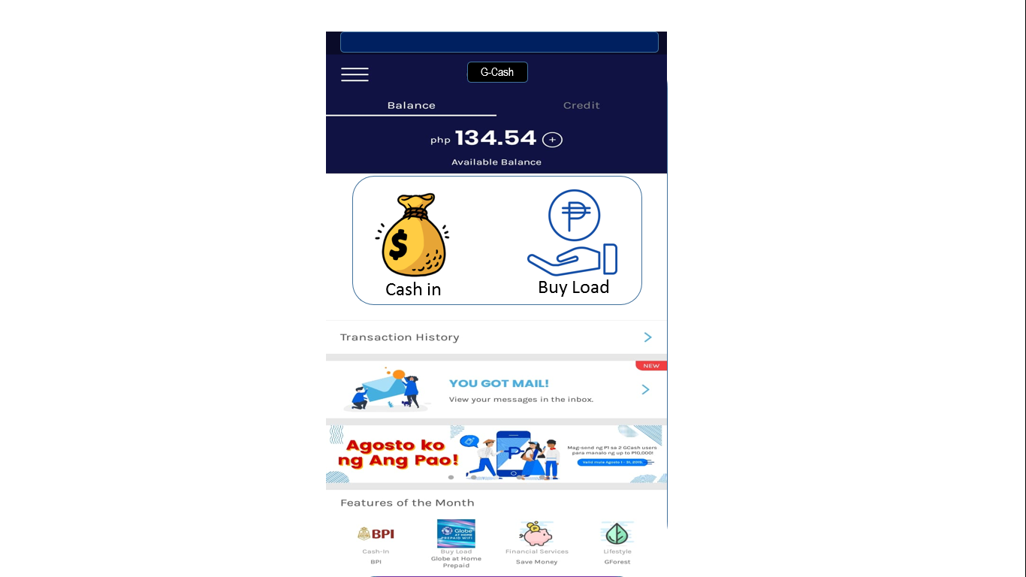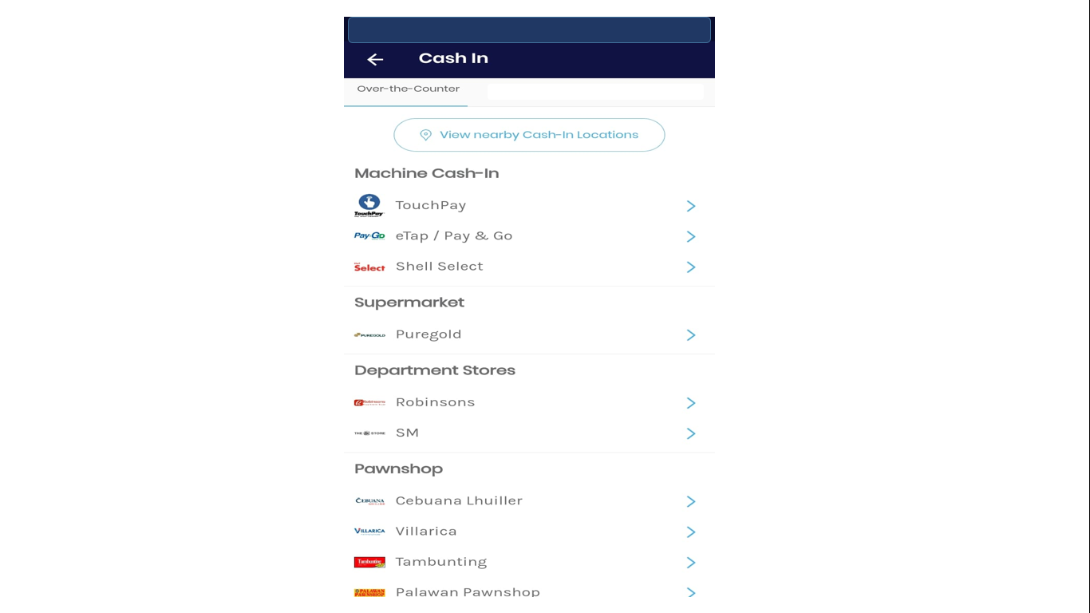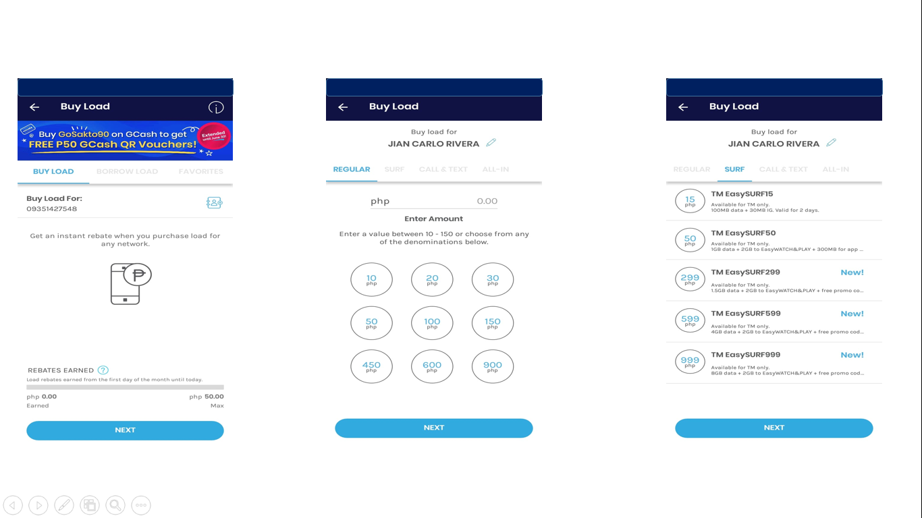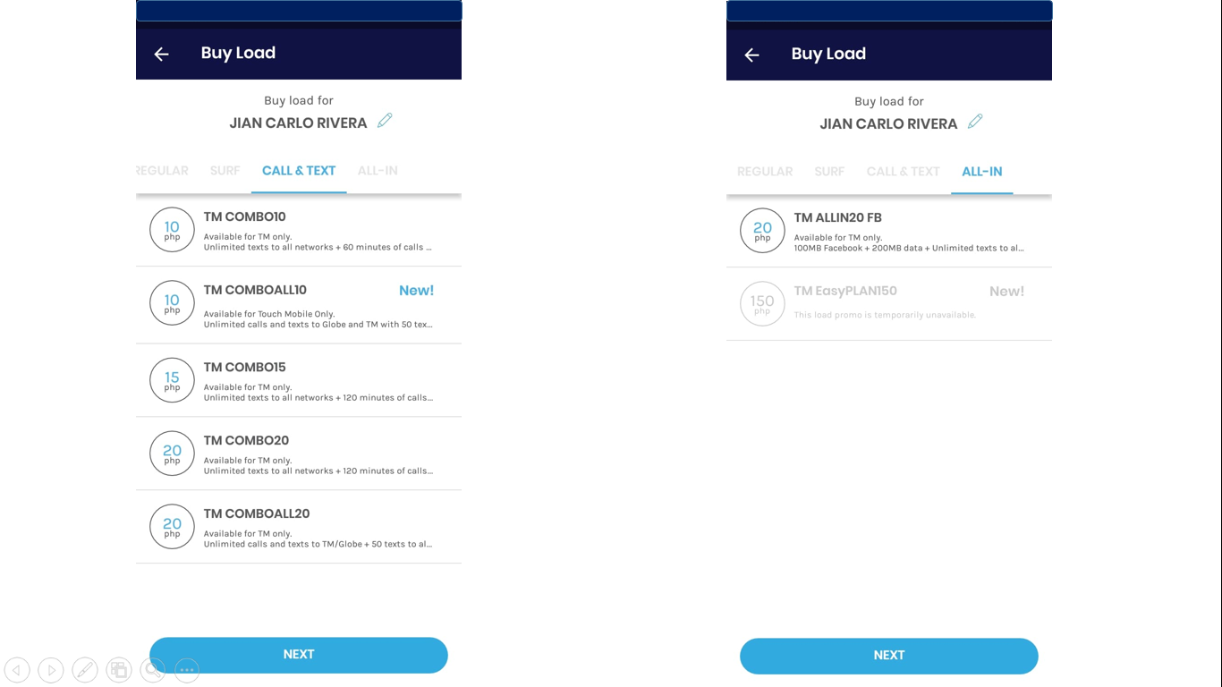

I developed this MOBILE APP for everyone especially for the students. In Gcash, you can save money, load credits and cash in. I simplified the APP so that everyone can easily understand the design. I only used a few colors since if I used too many it will be confusing to look at. I also enlarged the fonts a bit for better readability. This APP can also be accessed using smartphones. Its really good for students.